**PROJECT REPORT**

**WING IN GROUND EFFECT**

***Submitted in partial fulfillment of***

***the requirements for the award of degree of***

**BACHELOR OF TECHNOLOGY**

**In**

**MECHANICAL ENGINEERING**

**By**

**ARAVIND V G (Reg.No:14016156)**

**AANANTHAN M (Reg.No:14016123)**

**HORMESE THARAKAN (Reg.No:14016178)**

**GOURI SHANKAR J (Reg.No:14016175)**



**SCMS SCHOOL OF ENGINEERING AND TECHNOLOGY**

***(Affiliated to M.G. University)***

**VIDYA NAGAR, PALISSERY, KARUKUTTY**

**ERNAKULAM – 683 582**

**April 2018**

**BONAFIDE CERTIFICATE**

This is to certify that this report entitled **“WING IN GROUND EFFECT” submitted by GOURI SHANKAR J (Reg. No. 14016175) ARAVIND V G (Reg.No:14016156) AANANTHAN M (Reg.No:14016123) HORMESE THARAKAN (Reg.No:14016178)** in partial fulfillment of the requirements for the award of Bachelor of Technology Degree in Mechanical Engineering at SCMS School Of Engineering And Technology is an authentic work carried out by him during the year 2018 under my supervision and guidance.

Dr.SHEEJA JANARDHANAN Dr Venu P

Project Guide Head

SSET,Karukutty

**ACKNOWLEDGEMENT**

I am greatly indebted to Dr. Praveensal C J., Principal, SSET and Dr.Venu P, Head of Department of Mechanical Engineering, SSET, who whole heartedly granted me the permission to conduct this project.

I would like to thank my project guide Dr. Sheeja Janardhanan, Professor, Department of Mechanical Engineering ,SSET who has given me valuable guidance and support. Also, I would like to thank Mr. Vishnu, Assistant Professor, Department of Mechanical Engineering, SSET who support and instruct me all the way.

I would like to express my sincere gratitude to all the teachers of Mechanical Engineering Department who gave me moral and technical support. I would also like to thank my friends and family members for providing me with necessary resources and support. Last but not the least, I would like to thank God Almighty for helping me to finish this project hassle free.

**ABSTRACT**

Wing-in-Ground vehicles and aerodynamically assisted boats take advantage of increased lift and reduced drag of wing sections in the ground proximity. At relatively low speeds or heavy payloads of these craft, a flap at the wing trailing edge can be applied to boost the aerodynamic lift. The influence of a flap on the two-dimensional NACA 4412 airfoil in viscous ground-effect flow is numerically investigated in this study. The computational method consists of a steady-state, incompressible, finite volume method utilizing the K-epsilon turbulence model. Grid generation and solution of the Navier-Stokes equations are completed using computer program Fluent. The code is validated against published experimental and numerical results of unbounded flow with a flap, as well as ground-effect motion without a flap. Aerodynamic forces are calculated, and the effects of Reynolds number and ground height are presented for the airfoil. Changes in the flow introduced with the change in ground height are also discussed.

**LIST OF CONTENTS**

**CONTENTS :**

|  |  |
| --- | --- |
| BONAFIDE CERTIFICATE |  |
| ACKNOWLEDGEMENT |  |
| ABSTRACT |  |
| LIST OF CONTENTS |  |

|  |  |  |
| --- | --- | --- |
| CHAPTER 1 | INTRODUCTION |  |
| 1.1 | PRINCIPLE OF GROUND EFFECT |  |
| 1.2 | WINGS NEAR THE GROUND OR NEAR WATER |  |
| 1.3 | WEAK (CLASSICAL) GROUND EFFECT REGIME |  |
| 1.4 | GROUND EFFECT VEHICLE |  |
| 1.5 | DESIGN |  |
| 1.6 | WING CONFIGURATIONS |  |
| CHAPTER 2 | LITERATURE REVIEW |  |
| CHAPTER 3 | INITIAL WORK |  |
| 3.1 | NACA 4412 AIRFOIL |  |
| 3.2 | NACA 4412 AIRFOIL CHARACTERISTICS |  |
| 3.3 | 2D ANALYSIS OF NACA 4412 AIRFOIL |  |
| 3.4 | LIFT AND DRAG |  |
| 3.5 | SIMULATION |  |
| 3.6 | MODELLING AND SIMULATION |  |
| 3.7 | POST-PROCESSING |  |
| CHAPTER 4 | RESULTS FROM SIMULATION |  |
| 4.1 | CONTOUR OF PRESSURE COEFFICIENT FOR VARIOUS H/C VALUES |  |
| 4.2 | CONTOUR OF VELOCITY MAGNITUDE FOR VARIOUS H/C VALUES |  |
| CHAPTER 5 | RESULT |  |
| CHAPTER 6 | CONCLUSION |  |
| CHAPTER 7 | REFERENCES |  |

|  |  |  |
| --- | --- | --- |
|  | LUN-CLASS EKRANOPLAN |  |
|  | TANDEM-AIRFOIL FLAIRBOAT |  |
|  | NACA 4412 PLOT |  |
|  | AIRFOIL CHARACTERISTICS GRAPHS |  |
|  | CO-ORDINATE POINTS |  |
|  | LIFT AND DRAG |  |
|  | MESH FILE |  |
|  | STATIC PRESSURE AND VELOCITY PLOT |  |
|  | CONTOUR OF PRESSURE COEFFICIENT |  |
|  | CONTOUR OF VELOCITY MAGNITUDE |  |
|  | FORCE VS HEIGHT RATIO |  |

**LIST OF FIGURES**

**CHAPTER-1**

**INTRODUCTION**

High-speed, high-payload marine and amphibious transportation means benefit from using aerodynamic lift enhanced in ground vicinity. Various types of Wing-in--Ground (WIG) craft, mainly experimental, were constructed and tested in the last century (Rozhdestvensky, 2006). The most effective lift increase and drag reduction are obtained in the so-called extreme-ground flight regimes, roughly corresponding to the wing height over the ground surface being less than the wing chord. A new generation of aerodynamically assisted transport platforms using Power Augmented Ram (PAR) principle has been under development (Gallington, 1987; Kirillovykh and Privalov, 1996; Matveev, 2008). PAR craft operate in the extreme ground effect and rely on both aerodynamic and jet support. The development of complex ground-effect vehicles is hampered by high costs and accuracy issues in conducting experimental studies. Hence, the application of rapidly advancing CFD methods can help the engineering community make a significant progress in the air-assisted fast transportation.

The Wing-in-Ground effect, taking place when an airfoil flies in close proximity to the ground, provides beneficial aerodynamic properties. As the airfoil altitude approaches one wing span, the wingtip vortices become partly blocked by the ground, reducing the lift-induced drag and increasing lift. Further decreasing the ground height to within a small fraction of the wing chord, corresponding to the extreme ground effect, will trap flow underneath the airfoil, providing a high pressure ram effect which significantly increases the aerodynamic lift. It is apparent that the span-based ground effect is a three-dimensional phenomenon. However, the nearly two-dimensional chord-based effect dominates in the extreme ground proximity, when endplates are employed or large-aspect ratio airfoils are utilized.

Many WIG vehicles are designed to skim above water or a relatively flat solid surface. At low speeds or on heavy loaded craft a flap is employed at the trailing edge of the airfoil to strongly augment the airfoil lift. By adjusting the flap position, flow around the airfoil can be controlled, in turn providing control of the aerodynamic properties of the airfoil. In many cases where ground height and the wing attack angle are relatively fixed, a flap can be used to regulate the aerodynamic lift of the vehicle in ground vicinity.

A variety of inviscid numerical methods have been applied in the past for calculating ground-effect flows and even simulating dynamics of WIG craft (Gallington et al., two-dimensional incompressible flows around airfoils in ground effect. A finite volume method employing the k-ε turbulence model was used on an NACA 4412 airfoil by Hsiun and Chen (1996) along with a fixed ground boundary condition. They concluded that a decrease in lift was found in the extreme ground effect due to the boundary layer created between the fixed ground and free stream flow. Different ground boundary conditions on the NACA 4412 airfoil were studied by Barber et al. (1998). They note that the fixed ground condition is unrealistic for WIG craft, and propose the use of a moving ground at the free stream speed. A finite difference scheme and the Baldwin-Lomax turbulence model are used by Chun and Chang (2003) in their investigation of the fixed and moving ground conditions for an NACA 4412 airfoil. Again, they also see a significant difference between a fixed and moving ground. All of the above numerical models, which use the moving ground boundary condition, predict an increase in lift during ground-effect flight, although there is some variation in the magnitude of predicted forces. A few modeling analyses of three-dimensional WIG configurations by viscous solvers were also accomplished (Hirata and Hino, 1997; Wu and Rozhdestvensky, 2001).

Experimental data for wing sections in proximity to fixed ground and moving ground are available in the literature (Hayashi and Endo, 1978). These data correspond to flow of Reynolds number on the order of 105. At these Reynolds numbers the flow is known to be generally laminar on a significant portion of the chord, which makes it difficult to extrapolate such data even for small WIG craft. Kikuchi et al. (2002) present results obtained on a NACA 4412 airfoil towed at a Reynolds number of 8×105. Although the flow is still below the general WIG operating range, practical aerodynamic trends are obtained. They conclude that the ground effect augments the lift in all cases in which geometry does not create the Venturi effect below the airfoil.

Little published research has been found for the use of a flap in the extreme proximity to the ground. Most studied configurations were complicated PAR systems (Huffman and Jackson, 1974; Krause, 1997). Serebrisky and Biachev (1946) tested Clark-Y sections by the method of images in this region and found that use of flap in ground effect improves the aerodynamic efficiency for small angles of attack. Numerous experimental data collected by Abbott and Doenhoff (1959) show that a flap can significantly augment the lift in the free airflow. The flap application has been numerically and experimentally studied by Steinbach and Jacob (1991) in the distant ground effect, with height-tochord ratio from around one quarter to above one. Their numerical technique consisted of a panel method, which was iterated with boundary layer and rear displacement models to account for viscosity and separation. It is concluded that wing systems with excessive flap-slat mechanization are often unfavorable in the distant ground effect as the wing effective camber produces a negative ground effect. Their results also show that as a high-lift airfoil with a flap approaches the ground, the flap efficiency decreases, and the separation point moves further upstream.

However, nearly flat lower airfoil surfaces and moderate flap deflections and attack angles are known to be quite beneficial in ground proximity. The goal of this paper is to investigate favorable trailing-edge flap configurations that improve aerodynamic characteristics of the NACA 4412 wing section in the extreme ground effect. The extreme ground effect region has been chosen as it provides the most beneficial aerodynamic properties for ground-effect vehicles and obtained numerical solutions are generally steady. As a wing with flap moves farther from the ground, unsteady effects begin to take place and an unsteady solution is required. In this work, a numerical study of viscous ground effect flow is completed using the commercial code Fluent 6.3.

* 1. **PRINCIPLE OF GROUND EFFECT**

When an aircraft flies at a ground level approximately at or below the length of the aircraft's [wingspan](https://en.wikipedia.org/wiki/Wingspan) or helicopter's rotor diameter, there occurs, depending on airfoil and aircraft design, an often noticeable ground effect. This is caused primarily by the ground interrupting the [wingtip vortices](https://en.wikipedia.org/wiki/Wingtip_vortices) and [downwash](https://en.wikipedia.org/wiki/Downwash) behind the wing. When a wing is flown very close to the ground, wingtip vortices are unable to form effectively due to the obstruction of the ground. The result is lower [induced drag](https://en.wikipedia.org/wiki/Induced_drag), which increases the [speed](https://en.wikipedia.org/wiki/Speed) and [lift](https://en.wikipedia.org/wiki/Lift_(force)) of the aircraft.

A wing generates lift by deflecting the oncoming air mass (relative wind) downward. The deflected or "turned" flow of air creates a resultant force on the wing in the opposite direction (Newton's 3rd law). The resultant force is identified as lift. Flying close to a surface increases air pressure on the lower wing surface, nicknamed the "ram" or "cushion" effect, and thereby improves the aircraft lift-to-drag ratio. The lower/nearer the wing is with regards to the ground, the more pronounced the ground effect becomes. While in the ground effect, the wing requires a lower [angle of attack](https://en.wikipedia.org/wiki/Angle_of_attack) to produce the same amount of lift. If the angle of attack and [velocity](https://en.wikipedia.org/wiki/Velocity) remain constant, an increase in the lift coefficient ensues, which accounts for the "floating" effect. Ground effect also alters [thrust](https://en.wikipedia.org/wiki/Thrust) versus velocity, where reduced induced drag requires less thrust in order to maintain the same velocity.

[Low winged aircraft](https://en.wikipedia.org/wiki/Low_wing) are more affected by ground effect than [high wing](https://en.wikipedia.org/wiki/High_wing) aircraft. Due to the change in up-wash, down-wash, and wingtip vortices there may be errors in the airspeed system while in ground effect due to changes in the local pressure at the [static source](https://en.wikipedia.org/wiki/Pitot_tube).

Another important issue regarding ground effect is that the makeup of the surface directly affects the intensity; this is to say that a concrete or other smooth hard surface will produce more effect than water or broken ground.

**1.2 WINGS NEAR THE GROUND OR NEAR WATER**

When swallows shoot across a lake at dusk to feed on insects and when flying fish are airborne, their wings are just inches away from the water surface. The same is true during the take off and landing phases of airplanes. In all of these examples the wings are at a distance of approximately a semi-span from the surface. Airplanes certainly do not usually descend to within a chord length of the ground. Nevertheless, the effect of the ground on an airplane operating in its vicinity has been recognized for quite some time, especially by pilots who found that their craft seemed to ride on a cushion of air just above the runway. Pilots on long transoceanic voyages found that flight near the water was very stable and considerably extended the range. The conclusion was that a wing near the ground experiences more lift and less drag than an isolated wing, i.e., a wing which is far away from the ground.

The flow field around an airplane operating at a height of approximately a semi span above the ground is only affected by the presence of the ground at second order, meaning that the ground effect changes the flow-field by less than ten percent. This is termed the weak ground effect regime. If the airplane is allowed to descend to within a chord length of the ground, the ground becomes a leading order influence on the flowfield, meaning that the ground effect changes the flowfield by more than ten percent. This situation involves the intermediate ground effect regime.

**1.3 WEAK (CLASSICAL) GROUND EFFECT REGIME**

This flow regime entails ground clearance ratios (height-to-chord) that are greater than 3 and includes the case of aircraft flying above water or above runways. Although the ground has only a second order impact upon the flow fleld, airplanes experience a pronounced air cushion. There is an increase of the lift-to-drag ratio, and the reduced drag results in a lower fuel consumption. The cushioning effect is the reason for the often smooth touchdowns and take offs of aircraft, as well as for the prolonged glide (floating) of low-wing airplanes on landing. This prolonged glide is not usually desirable in that it increases the landing distance. The increased fuel economy was utilized by the Dornier Wal flying boats and by the Do X flying boats of the German postal service when they were operating in the south Atlantic in the 1930s .The Do X was built in the 1920s. With a wingspan of 137 feet, a length of 131 feet, a flight weight of 123,000 pounds (54.5 tons) and twelve Engines in back-to-back pairs for thrust, it was the largest aircraft of its day. In 1927, Charles Lindbergh reported taking advantage of the ground effect to increase range.

The weak ground effect can be explained in a variety of ways. The effect of the ground is to prevent higher pressure air from escaping from underneath the wing to the top side. The strength of the wingtip vortex is therefore reduced, as is the associated downwash. The reduction in downwash causes the lift vector to tilt forward, thereby reducing the induced drag. The increased lift-to-drag ratio is due mainly to this reduced drag.

**1.4 GROUND EFFECT VEHICLE**

Many vehicles have a design that makes use of the wing in ground effect. Although all airplanes fly through ground effect at some point, craft that do so in a dedicated manner are designed in such a way that their wings are normally unable to take them into flight out of ground effect (free flight). Those that can fly out of ground effect are often capable of only a short distance take-off into free flight. Because of this, these craft are often licensed as ships rather than as aircraft. These specially designed craft may use [delta wings](https://en.wikipedia.org/wiki/Delta_wing), [ekranoplan](https://en.wikipedia.org/wiki/Ekranoplan" \o "Ekranoplan) wings or [tandem wings](https://en.wikipedia.org/wiki/Tandem_wing).

**1.5 DESIGN**

A ground-effect vehicle needs some forward velocity to produce lift dynamically and the principal benefit of operating a wing in ground effect is to reduce its [lift-dependent drag](https://en.wikipedia.org/wiki/Lift-induced_drag). The basic design principle is that the closer the wing operates to an external surface such as the ground, said to be [in ground effect](https://en.wikipedia.org/wiki/Ground_effect_in_aircraft), the more efficient it becomes.

An [airfoil](https://en.wikipedia.org/wiki/Airfoil" \o "Airfoil) passing through air increases air pressure on the underside, while decreasing pressure across the top. The high and low pressures are maintained until they flow off the ends of the wings, where they form vortices which in turn are the major cause of [lift-induced drag](https://en.wikipedia.org/wiki/Lift-induced_drag)—normally a large portion of the drag affecting an aircraft. The higher the aspect ratio of the wing (that is, the longer and skinnier it is), the less induced drag created for each unit of lift and the greater the efficiency of the particular wing. This is the primary reason [gliders](https://en.wikipedia.org/wiki/Glider_(aircraft)) have long and skinny wings.

Placing the same wing near a surface such as the water or the ground has the effect of greatly increasing the aspect ratio, but without having the complications associated with a long and slender wing, so that the short stubs on an Ekranoplan can produce just as much lift as the much larger wing on a transport aircraft, though it can only do this when close to the earth's surface. Once sufficient speed has built up, some GEVs may be capable of leaving ground effect and functioning as normal aircraft until they approach their destination. The distinguishing characteristic is that they are unable to land or take off without a significant amount of help from the ground effect cushion, and cannot climb until they have reached a much higher speed.

A GEV is sometimes characterized as a transition between a [hovercraft](https://en.wikipedia.org/wiki/Hovercraft) and an [aircraft](https://en.wikipedia.org/wiki/Aircraft), although this is not correct as a hovercraft is statically supported upon a cushion of pressurised air from an onboard downward-directed fan. Some GEV designs, such as the Russian *Lun* and *Dingo*, have used forced blowing under the wing by auxiliary engines to increase the high pressure area under the wing to assist the takeoff; however they differ from hovercraft in still requiring forward motion to generate sufficient lift to fly.

**1.6**  **WING CONFIGURATIONS**

EKRANOPLANE WING

This was the profile designed by [Rostislav Alexeyev](https://en.wikipedia.org/wiki/Rostislav_Alexeyev" \o "Rostislav Alexeyev). The wings are significantly shorter than comparable aircraft, and this configuration requires a high aft-placed horizontal tail to maintain stability. The pitch and altitude stability comes from the lift slope difference between a front low wing in ground effect (commonly the main wing) and an aft, higher-located second wing nearly out of ground effect (generally named a stabilizer).

REVERSE DELTA WING

Developed by [Alexander Lippisch](https://en.wikipedia.org/wiki/Alexander_Lippisch), this wing allows stable flight in ground effect through self stabilization. This is the main Class B form of ground effect craft.

TANDEM WINGS

Tandem wing can have two configurations:

* a [biplane](https://en.wikipedia.org/wiki/Biplane)-style type-1 utilising a shoulder-mounted main lift wing and belly-mounted [sponsons](https://en.wikipedia.org/wiki/Sponson" \o "Sponson) similar to those on combat and transport helicopters
* a [canard](https://en.wikipedia.org/wiki/Canard_(aeronautics))-style type-2 with a mid-size horizontal wing[[note 2]](https://en.wikipedia.org/wiki/Ground_effect_vehicle#cite_note-2) near the nose of the craft directing airflow under the main lift airfoil. This type-2 tandem design is a major improvement during takeoff as it creates an air cushion to lift the craft above the water at a lower speed, thereby reducing water drag which is the biggest obstacle to successful seaplane launches.
* a tandem wing style with double-wing system as tandem-airfoil flairboat constructions by the aerodynamic specialist Dipl.Ing. Günther W. Jörg. This system is self-stabilizing and provides secure, comfortable and high-efficiency operation.

**CHAPTER-2**

**LITERATURE REVIEW**

By the 1920s, the *ground effect* phenomenon was well-known, as pilots found that their airplanes appeared to become more efficient as they neared the runway surface during landing. In 1934 the US [National Advisory Committee for Aeronautics](https://en.wikipedia.org/wiki/National_Advisory_Committee_for_Aeronautics) issued Technical Memorandum 771, *Ground Effect on the Takeoff and Landing of Airplanes*, which was a translation into English of a summary of research up to that point on the subject. The French author Maurice Le Sueur had added a suggestion based on this phenomenon: "Here the imagination of inventors is offered a vast field. The ground interference reduces the power required for level flight in large proportions, so here is a means of rapid and at the same time *economic* locomotion: Design an airplane which is always within the ground-interference zone. At first glance this apparatus is dangerous because the ground is uneven and the altitude called skimming permits no freedom of maneuver. But on large-sized aircraft, over water, the question may be attempted ..."

By the 1960s, the technology started maturing, in large part due to the independent contributions of [Rostislav Alexeyev](https://en.wikipedia.org/wiki/Rostislav_Alexeyev" \o "Rostislav Alexeyev) in the [Soviet Union](https://en.wikipedia.org/wiki/Soviet_Union) and [German](https://en.wikipedia.org/wiki/Germany) [Alexander Lippisch](https://en.wikipedia.org/wiki/Alexander_Lippisch), working in the [United States](https://en.wikipedia.org/wiki/United_States). Alexeyev worked from his background as a ship designer whereas Lippisch worked as an aeronautical engineer. The influence of Alexeyev and Lippisch remains noticeable in most GEV vehicles seen today.

SOVIENT UNION

Led by Alexeyev, the Soviet Central Hydrofoil Design Bureau was the center of ground-effect craft development in the USSR. The vehicle came to be known as an ekranoplan. The military potential for such a craft was soon recognized and Alexeyev received support and financial resources from Soviet leader [Nikita Khrushchev](https://en.wikipedia.org/wiki/Nikita_Khrushchev).

Some manned and unmanned prototypes were built, ranging up to eight tons in [displacement](https://en.wikipedia.org/wiki/Displacement_(ship)). This led to the development of a 550-ton military *ekranoplan* of 92 m (302 ft) length. The craft was dubbed the [*Caspian Sea Monster*](https://en.wikipedia.org/wiki/Caspian_Sea_Monster) by U.S. intelligence experts, after a huge, unknown craft was spotted on satellite reconnaissance photos of the Caspian Sea area in the 1960s. With its short wings, it looked airplane-like in planform, but would obviously be incapable of flight. Although it was designed to travel a maximum of 3 m (9.8 ft) above the sea, it was found to be most efficient at 20 m (66 ft), reaching a top speed of 300–400 KN (560–740 km/h; 350–460 mph) in research flights.

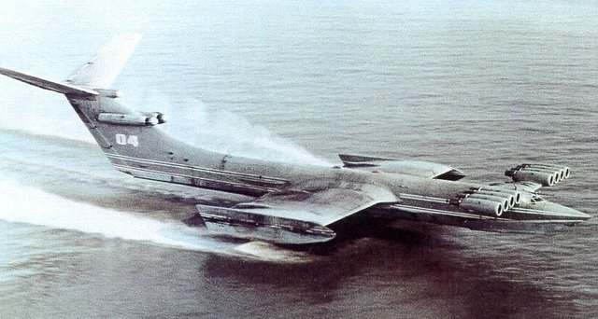

Lun-class ekranoplan

The Soviet *ekranoplan* program continued with the support of [Minister of Defence](https://en.wikipedia.org/wiki/Minister_of_Defence_(Soviet_Union)) [Dmitriy Ustinov](https://en.wikipedia.org/wiki/Dmitriy_Ustinov" \o "Dmitriy Ustinov). It produced the most successful *ekranoplan* so far, the 125-ton [A-90 *Orlyonok*](https://en.wikipedia.org/wiki/A-90_Orlyonok). These craft were originally developed as high-speed military transports and were usually based on the shores of the [Caspian Sea](https://en.wikipedia.org/wiki/Caspian_Sea) and [Black Sea](https://en.wikipedia.org/wiki/Black_Sea). The Soviet Navy ordered 120 *Orlyonok*-class *ekranoplans*, but this figure was later reduced to fewer than 30 vessels, with planned deployment mainly in the Black Sea and [Baltic Sea](https://en.wikipedia.org/wiki/Baltic_Sea) fleets.

A few *Orlyonoks* served with the [Soviet Navy](https://en.wikipedia.org/wiki/Soviet_Navy) from 1979 to 1992. In 1987, the 400-ton *[Lun](https://en.wikipedia.org/wiki/Lun-class_ekranoplan" \o "Lun-class ekranoplan)*[-class](https://en.wikipedia.org/wiki/Lun-class_ekranoplan" \o "Lun-class ekranoplan)*[ekranoplan](https://en.wikipedia.org/wiki/Lun-class_ekranoplan" \o "Lun-class ekranoplan)* was built as a missile launcher. A second *Lun*, renamed *Spasatel*, was laid down as a rescue vessel, but was never finished. The two major problems that the Soviet *ekranoplans* faced were poor [longitudinal stability](https://en.wikipedia.org/wiki/Longitudinal_stability) and a need for reliable navigation.

Minister Ustinov died in 1985, and the new Minister of Defence, Marshal [Sokolov](https://en.wikipedia.org/wiki/Sergei_Sokolov_(commander)" \o "Sergei Sokolov (commander)), cancelled funding for the program. Only three operational *Orlyonok*-class *ekranoplans* (with revised hull design) and one *Lun*-class *ekranoplan* remained at a naval base near [Kaspiysk](https://en.wikipedia.org/wiki/Kaspiysk" \o "Kaspiysk).

Since the [dissolution of the Soviet Union](https://en.wikipedia.org/wiki/Dissolution_of_the_Soviet_Union), *ekranoplans* have been produced by the Volga Shipyard in [Nizhniy Novgorod](https://en.wikipedia.org/wiki/Nizhniy_Novgorod). Smaller *ekranoplans* for non-military use have been under development. The CHDB had already developed the eight-seat Volga-2 in 1985, and Technologies and Transport is developing a smaller version called the Amphistar. [Beriev](https://en.wikipedia.org/wiki/Beriev" \o "Beriev) proposed a large craft of the type, the Be-2500, as a "flying ship" cargo carrier, but nothing came of the project.

LIPPISH TYPE AND HANNO FISHCHER

In Germany, Lippisch was asked to build a very fast boat for [American](https://en.wikipedia.org/wiki/United_States) businessman [Arthur A. Collins](https://en.wikipedia.org/wiki/Arthur_A._Collins). In 1963 Lippisch developed the [X-112](https://en.wikipedia.org/wiki/Collins_X-112), a revolutionary design with reversed delta wing and T-tail. This design proved to be stable and efficient in ground effect and even though it was successfully tested, Collins decided to stop the project and sold the patents to a German company called [Rhein Flugzeugbau](https://en.wikipedia.org/wiki/Rhein_Flugzeugbau_GmbH" \o "Rhein Flugzeugbau GmbH) (RFB), which further developed the inverse delta concept into the [X-113](https://en.wikipedia.org/wiki/RFB_X-113) and the six seat [X-114](https://en.wikipedia.org/wiki/RFB_X-114). These craft could be flown out of ground effect so that, for example, peninsulas could be overflown.

Hanno Fischer took over the works from RFB and created his own company, Fischer Flugmechanik, which eventually completed two models. The Airfisch 3 carried two persons, and the FS-8 carried six persons. The FS-8 was to be developed by Fischer Flugmechanik for a Singapore-Australian joint venture called Flightship. Powered by a V8 Chevrolet automobile engine rated at 337 kW, the prototype made its first flight in February 2001 in the Netherlands. The company no longer exists but the prototype craft was bought by Wigetworks, a company based in Singapore and renamed as AirFish 8. In 2010, that vehicle was registered as a ship in the Singapore Registry of Ships.

The [University of Duisburg-Essen](https://en.wikipedia.org/wiki/University_of_Duisburg-Essen) is supporting an ongoing research project to develop the *Hoverwing*.

GUNTHER-JORG-TYPE TANDEM-AIRFOIL FLAIRBOAT

German engineer Günther Jörg, who had worked on Alexeyev's first designs and was familiar with the challenges of GEV design, developed a GEV with two wings in a tandem arrangement, the Jörg-II. It was the third, manned, tandem-airfoil boat, named "Skimmerfoil", which was developed during his consultancy period in South Africa. It was a simple and low-cost design of a first 4-seater tandem-airfoil flairboat completely constructed of aluminium. The prototype has been in the [SAAF Port Elizabeth](https://en.wikipedia.org/wiki/South_African_Air_Force_Museum#Port_Elizabeth) Museum since 4 July 2007, remained there till (2013) and is now in private use. Pictures of the museum show the boat after a period of some years outside the museum and without protection against the sun.

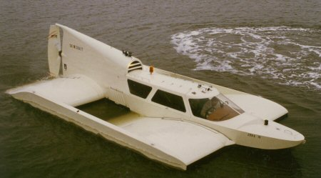

TANDEM-AIRFOIL FLAIRBOAT

The consultancy of Dipl. Ing. Günther Jörg who was specialist and insider of German Airplane Industrie up from 1963 and a colleague of Alexander Lippisch and Hanno Fischer as well, was founded with a fundamental knowledge of Wing in ground effect physics, as well as results of fundamental tests under different conditions and designs having begun in 1960. During a period of more than 30 years Dipl. Ing. Gunther W. Jörg managed to built and fly successful a series of 15 different tandem-airfoil flairboats in different sizes and made of different materials.

The following tandem-airfoil flairboat (TAF) types had been built after a previous period of nearly 10 years of research and development:

1. TAB VII-3: First manned tandem W.I.G type Jörg, buing built at Technical University of Darmstadt, Akaflieg;
2. TAF VII-5: Second manned tandem-airfoil Flairboat, 2 seater made of wood.
3. TAF VIII-1: 2-seater tandem-airfoil flairboat built of GRP / Aluminium. A small serie of 6 Flairboats had been produced by former Botec Company.
4. TAF VIII-2: 4-seater tandem-airfoil Flairboat built of full aluminium (2 units) and built of GRP (3 Units)
5. TAF VIII-3: 8-seater tandemIrfoil Flairboat built of aluminium combined with GRP parts.
6. TAF VIII-4: 12-seater tandem Airfoil Flairboat built of aluminium combined with GRP parts as well.
7. TAF VIII-3B: 6-seater tandem-airfoil flairboat under carbon fibre composite construction.

Bigger concepts are: 25-seater, 32-seater, 60-seater, 80-seater and bigger up to the size of a passenger airplane.

All those tandem-airfoil flairboats are registered as motorboat and classified as type A WIG. In 1984, Gunther W. Jörg was decorated with "Philip Morris Award" for future transportation. In 1987, the Botec Company was founded. After his death in 2010 business is continued by his daughter and former assistant Ingrid Schellhaas with her company Tandem WIG Consulting.

SINCE THE 1980s

GEVs developed since the 1980s have been primarily smaller craft designed for the recreational and civilian ferry markets. [Germany](https://en.wikipedia.org/wiki/Germany), [Russia](https://en.wikipedia.org/wiki/Russia) and the [United States](https://en.wikipedia.org/wiki/United_States) have provided most of the momentum with some development in [Australia](https://en.wikipedia.org/wiki/Australia), [China](https://en.wikipedia.org/wiki/China), [Japan](https://en.wikipedia.org/wiki/Japan), [Korea](https://en.wikipedia.org/wiki/Korea) and [Taiwan](https://en.wikipedia.org/wiki/Taiwan). In these countries and regions, small craft up to ten seats have been designed and built. Other larger designs as ferries and heavy transports have been proposed, but have not been carried to fruition.

Besides the development of appropriate design and structural configuration, special automatic control systems and navigation systems are also being developed. These include special altimeters with high accuracy for small altitude measurements and also lesser dependence on weather conditions. After extensive research and experimentation, it has been shown that "phase [radio altimeters](https://en.wikipedia.org/wiki/Radio_altimeter)" are most suitable for such applications as compared to [laser altimeter](https://en.wikipedia.org/wiki/Laser_altimeter), isotropic or [ultrasonic altimeters](https://en.wikipedia.org/wiki/Sonic_altimeter).

Universal Hovercraft developed a flying hovercraft, a prototype of which first took flight in 1996. Since 1999, the company has offered plans, parts, kits and manufactured GEV hovercraft called the Hoverwing.

In Singapore, Wigetworks has continued development and obtained certification from Lloyd's Register for entry into class. On 31 March 2011 AirFish 8-001 became one of the first WIG to be flagged with the Singapore Registry of Ships, one of the largest ship registries. Wigetworks has also partnered with National University of Singapore's Engineering Department to develop higher capacity WIG craft.

In Korea, Wing Ship Technology Corporation has developed and tested a 50-seat passenger version of a WIG craft named the WSH-500.

Iran deployed three squadrons of [Bavar 2](https://en.wikipedia.org/wiki/Bavar_2" \o "Bavar 2) two-seat GEVs in September, 2010. This GEV carries one machine gun and surveillance gear, and incorporates features which reduce its radar signature in a similar manner to stealth. In October 2014, satellite images showed new images of the Ekranoplan in a shipyard in south of Iran. The Ekranoplan has two engines and no armament.

The designers [Burt Rutan](https://en.wikipedia.org/wiki/Burt_Rutan) in 2011 and Korolev in 2015 have shown ekranoplan projects.

Estonian transport company Sea Wolf Express plans to launch passenger service in 2019 between [Helsinki](https://en.wikipedia.org/wiki/Helsinki) and [Tallinn](https://en.wikipedia.org/wiki/Tallinn), a distance of 87 km taking only half an hour, using a Russian-built ground effect vehicle (GEV). The company has ordered 15 GEVs with maximum speed of 185 km/h and capacity of 12 passengers and they are built by Russian RDC Aqualines.

**CHAPTER-3**

**INITIAL WORK**

**3.1 NACA 4412 AIRFOIL**

The NACA airfoils are [airfoil](https://en.wikipedia.org/wiki/Airfoil) shapes for aircraft wings developed by the [National Advisory Committee for Aeronautics](https://en.wikipedia.org/wiki/National_Advisory_Committee_for_Aeronautics) (NACA). The shape of the NACA airfoils is described using a series of digits following the word "NACA". The parameters in the numerical code can be entered into equations to precisely generate the cross-section of the airfoil and calculate its properties.

FOUR DIGIT SERIES

The NACA four-digit wing sections define the profile by:

For example, the NACA 4412 airfoil has a maximum camber of 4% located 40% (0.4 chords) from the leading edge with a maximum thickness of 12% of the chord.

The NACA 0015 airfoil is symmetrical, the 00 indicating that it has no camber. The 15 indicates that the airfoil has a 15% thickness to chord length ratio: it is 15% as thick as it is long.

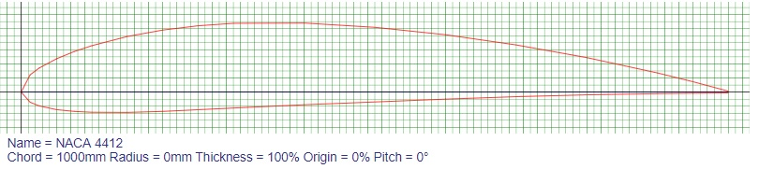

NACA 4412 plot

The NACA airfoil section is created from a camber line and a thickness distribution plotted perpendicular to the camber line. The equation for the camber line is split into sections either side of the point of maximum camber position (P). In order to calculate the position of the final airfoil envelope later the gradient of the camber line is also required. The equations are:

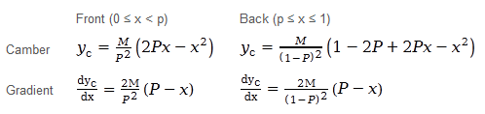

The thickness distribution is given by the equation:

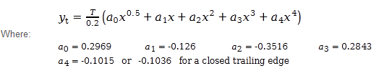 

* The constants a0 to a4 are for a 20% thick airfoil. The expression T/0.2 adjusts the constants to the required thickness.
* At the trailing edge (x=1) there is a finite thickness of 0.0021 chord width for a 20% airfoil. If a closed trailing edge is required the value of a4 can be adjusted.
* The value of yt is a half thickness and needs to be applied both sides of the camber line.

Using the equations above, for a given value of x it is possible to calculate the camber line position Y c, the gradient of the camber line and the thickness. The position of the upper and lower surface can then be calculated perpendicular to the camber line.

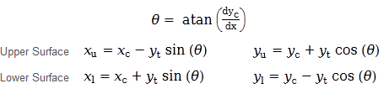

The most obvious way to plot the airfoil is to iterate through equally spaced values of x calculating the upper and lower surface coordinates. While this works, the points are more widely spaced around the leading edge where the curvature is greatest and flat sections can be seen on the plots. To group the points at the ends of the airfoil sections a cosine spacing is used with uniform increments of βCosine spacing

**3.2 NACA 4412 AIRFOIL CHARACTERISTICS**

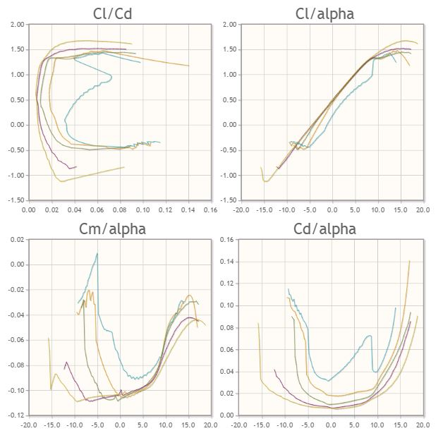

**3.3 2D ANALYSIS OF NACA 4412 AIRFOIL**

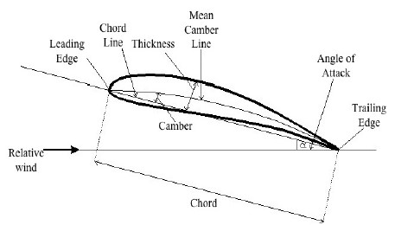

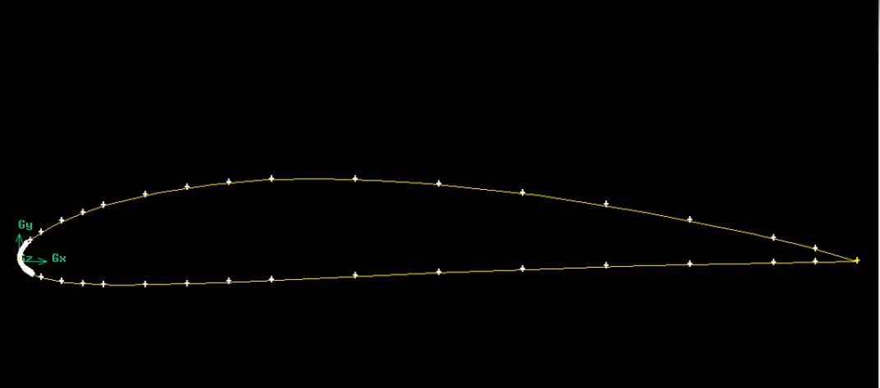

Geometry of the 2-D airfoil NACA 4412 was made using coordinate points from airfoil generator. The angle of attack was 0˚ and the length of airfoil was set as 1.0m.

The formatted point file was made and imported to ICEM CFD application. The points were carefully used to make the geometry for the simulation and making the mesh for the later simulation to be carried out. The centre point was taken as 0.5 from the leading edge.

Since ground effect is scene when the wing is in very close proximity to the ground the boundary of the mesh for simulation of the ground is initially kept at 0.5 times the chord length of the airfoil from the centre of the airfoil. The value of h/c ratio is changed to 0.75, 0.25, 0.10 to find the variation in lift produced due to ground effect due to the change in position of the wing in respect to ground. The value of temperature, viscosity, pressure are all kept constant and only the height from ground is varied.

**3.4 LIFT AND DRAG**

Lift on a body is defined as the force on the body in a direction normal to the flow direction. Lift will only be present if the fluid incorporates a circulatory flow about the body such as that which exists about a spinning cylinder. The velocity above the body is increased and so the static pressure is reduced. The velocity beneath is slowed down, giving an increase in static pressure. So, there is a normal force upwards called the lift force.

The drag on a body in an oncoming flow is defined as the force on the body in a direction parallel flow direction. For a windmill to operate efficiently the lift force should be high and drag force should be low. For small angles of attack, lift force is high and drag force is low.

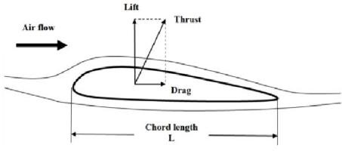

**3.5 SIMULATION**

COMPUTATIONAL FLUID DYNAMICS (CFD)

Computational fluid dynamics (CFD) is a branch of [fluid mechanics](https://en.wikipedia.org/wiki/Fluid_mechanics) that uses [numerical analysis](https://en.wikipedia.org/wiki/Numerical_analysis) and [data structures](https://en.wikipedia.org/wiki/Data_structure) to solve and analyze problems that involve [fluid flows](https://en.wikipedia.org/wiki/Fluid_dynamics). Computers are used to perform the calculations required to simulate the interaction of liquids and gases with surfaces defined by [boundary conditions](https://en.wikipedia.org/wiki/Boundary_value_problem#Boundary_value_conditions). With high-speed [supercomputers](https://en.wikipedia.org/wiki/Supercomputer), better solutions can be achieved. Ongoing research yields software that improves the accuracy and speed of complex simulation scenarios such as [transonic](https://en.wikipedia.org/wiki/Transonic) or [turbulent](https://en.wikipedia.org/wiki/Turbulence) flows. Initial experimental validation of such software is performed using a [wind tunnel](https://en.wikipedia.org/wiki/Wind_tunnel) with the final validation coming in full-scale testing.

METHODOLOGY

* The geometry and physical bounds of the problem can be designed using computer aided design(CAD).from there data can be suitably processed and fluid domain is extracted
* The volume occupied by the fluid is divided in to discrete cells(THE MESH)/it can be uniform or non-uniform structured or unstructured consisting of a combination of hexahedral, tetrahedral, prismatic, pyramidal or polyhedral elements
* The physical modelling is defined for examples the equations of fluid motion + enthalpy

+ radiation + species conservation

* Boundary condition are defined specifying the fluid behaviour and properties of all bounding surfaces a fluid domain. For transient problems initial conditions are also defined.
* The simulation is started and equation are solved iteratively as steady state or transient
* Finally a post processor is used of analysis and visualization of resulting solution

**3.6 MODELLING AND SIMULATION**

The first step of CFD simulation process which helps in describing the geometry in the best possible manner. One needs to identify the fluid domain of interest. The domain of interest is then further divided into smaller segments known as mesh generation step. There are different popular Pre-Processing software available in the market including: Gridgen, CFD-GEOM, ANSYS Meshing, ANSYS ICEM CFD, TGrid etc.

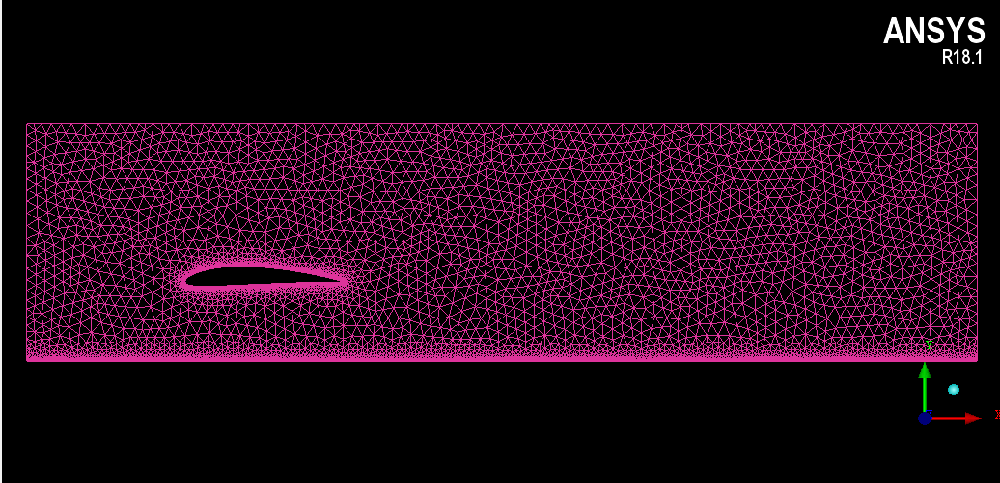

Mesh file

FLUENT parameters which are:

|  |  |
| --- | --- |
| Solver | Pressure based transient state |
| Viscous model | k-epsilon |
| Density (kg/m3) | 1.225 |
| Viscosity (kg/m-s) | 1.7894x10^-5 |
| Turbulent viscosity ratio | 10 |
| Inlet velocity | 30 m/s |
| Chord-length | 1 m |
| Momentum | Second order upwind |
| Pressure velocity coupling | Simple |

**3.7 POST-PROCESSING**

From the contours, we see that there is a region of high pressure at the leading edge (stagnation point) and region of low pressure on the upper surface of airfoil. From Bernoulli equation, we know that whenever there is high velocity, we have low pressure and vice versa. Figure shows the simulation outcomes of static pressure at angle of attack 0° with k-epsilon model. The pressure on the lower surface of the airfoil was greater than that of the incoming flow stream and as a result it effectively “pushed” the airfoil upward, normal to the incoming flow stream.

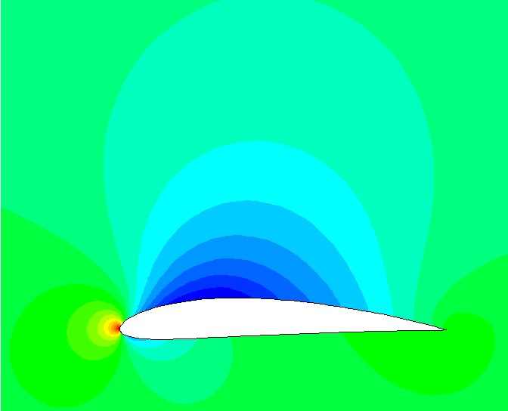 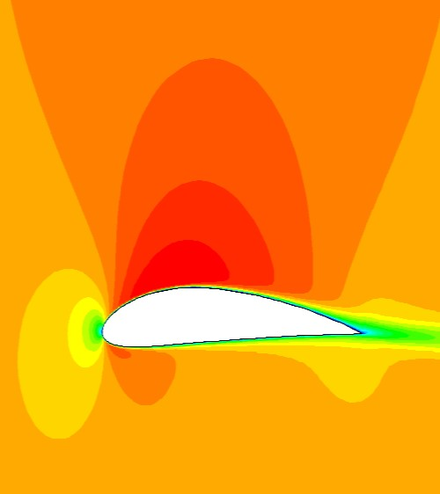

Static Pressure and velocity plot at 0° Angle of attack.

The graph of pressure contour shows a high pressure area below the airfoil due to the ground at close proximity. We can see vortex at the trailing edge of the airfoil which is due to the difference in pressure at the top and bottom of the airfoil. The low pressure area indicate the area of higher velocity. The leading edge experiences area of high pressure and is called the stagnation point.

The area under the airfoil has high pressure air under it which in turn gives a push in the upward direction hence producing lift.

The velocity magnitude contour shows the maximum and minimum velocity on the airfoil. The inlet velocity was given as 30 m/s. The leading edge the velocity is very low and this point is called the stagnation point. The low pressure area indicate the area of higher velocity. The leading edge experiences area of high pressure and is called the stagnation point. The area under the airfoil has high pressure air under it which in turn gives a push in the upward direction hence producing lift.

**CHAPTER-4**

**RESULTS FROM SIMULATION**

**4.1 CONTOUR OF PRESSURE COEFFICIENT FOR VARIOUS H/C VALUES**

h/c=0.75 h/c=0.5

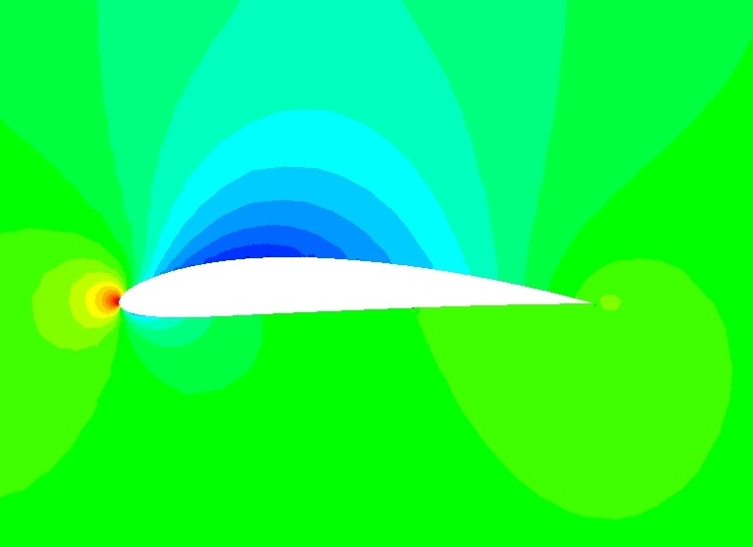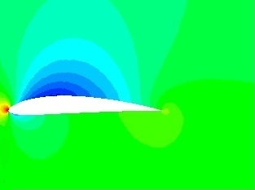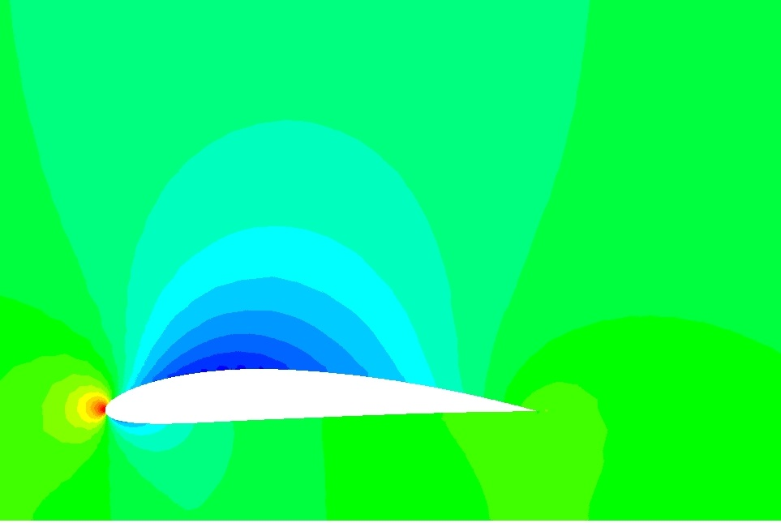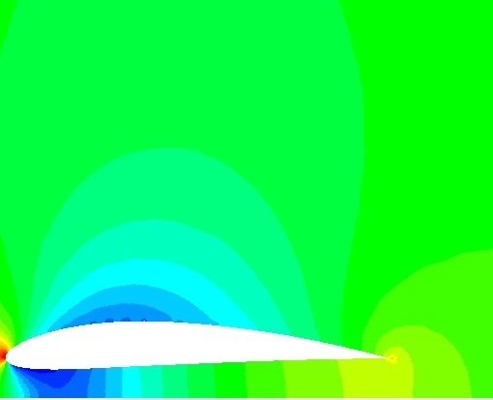

h/c=0.25 h/c=0.1

The pressure coefficient contour shows that there is significant amount of pressure on the lower side of the airfoil and has low pressure on the upper side. The contour of h/c=0.1 shows lower pressure below the airfoil which may cause instability. This is due to the existence flow passage between the airfoil’s bottom surface and the ground plane, which culminates in a suction effect.

**4.2 CONTOUR OF VELOCITY MAGNITUDE FOR VARIOUS H/C VALUES**

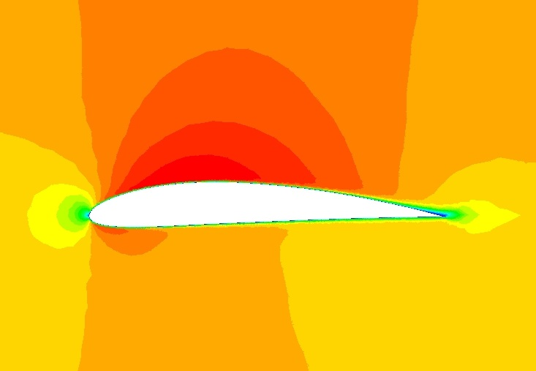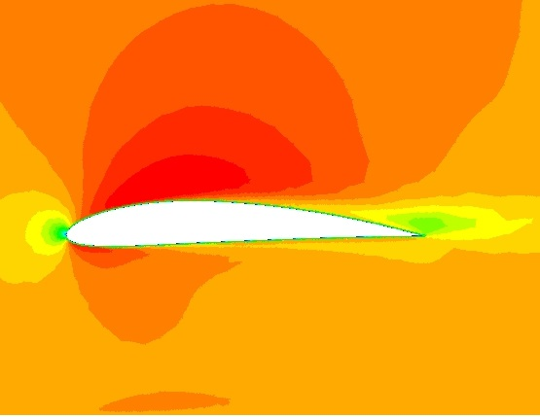

h/c=0.75 h/c=0.5

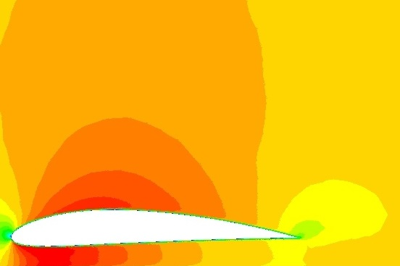 h/c=0.25 h/c=0.1

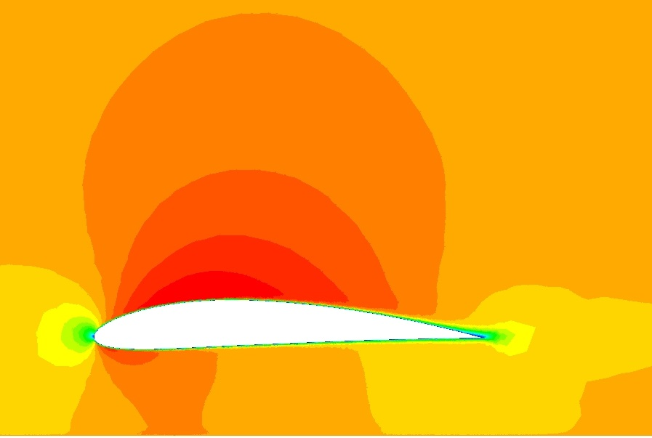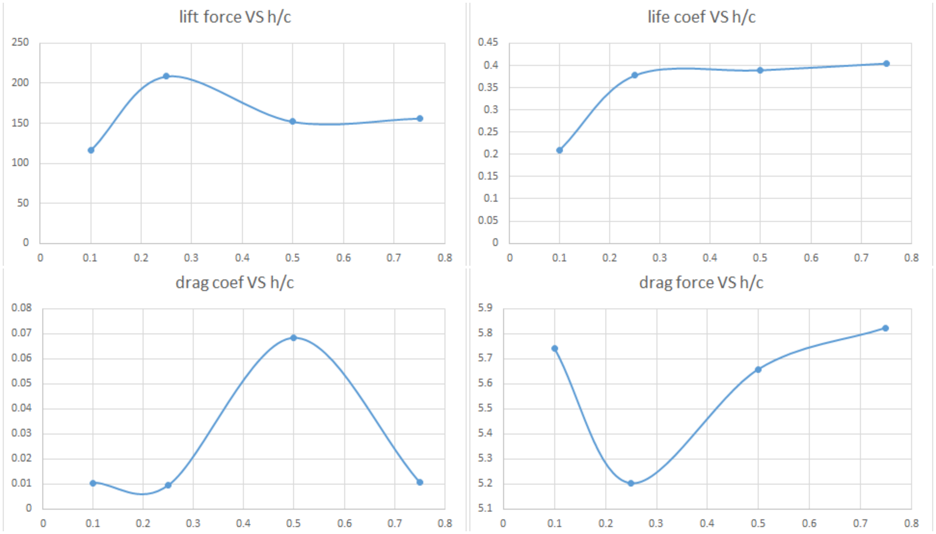

The value of lift and drag shows that the lift on the airfoil is higher at the vicinity of the ground and at near 0.25 we get the higher value of lift. The drag also is considerably low.

**CHAPTER-5**

**RESULT**

The CFD analysis of the airfoil at varying height from the ground has been completed and the results were obtained. The airfoil used had standard dimensions and was not altered. All simulation were done using Ansys fluent. The lift and drag forces acting on the airfoil were found and the variation of lift and drag for different h/c has been noted.

**CHAPTER-6**

**CONCLUSION**

The effect of ground effect can be utilized for higher amount of lift and lower induced drag to create vehicles that carry higher payload with better efficiency. The analysis of the airfoil is completed using Ansys Fluent software. The ground effect characteristics can be further improved by the introduction of flaps to the airfoil and also by changing the angle of attack the airfoil is placed. Further improvement in lift can be made with the reduction in wing tip vortices and by the in-depth analysis of the airfoil. The project imparted us knowledge on wing design, airfoil and modeling software.

**CHAPTER-7**

**REFERENCES**

1. S. Kandwal, Dr. S. Singh, “Computational Fluid Dynamics Study of Fluid Flow and Aerodynamic Forces on an Airfoil”, IJERT, Vol. 1 Issue 7, September – 2012.
2. Mr. Monir Chandrala, Prof. Abhishek Choubey, “ Prof. Bharat GuptaAerodynamic Analysis Of Horizontal Axis Wind Turbine Blade”, IJERA, Vol. 2, Issue6, November- December 2012.
3. Nathan logsdon, “a procedure for numerically analyzing airfoils and Wing sections”, The Faculty of the Department of Mechanical & Aerospace Engineering University of Missouri – Columbia, December 2006.
4. [www.airfoiltools.com](http://www.airfoiltools.com/)
5. Airfoil nomenclature.pdf
6. http://ocw.kfupm.edu.sa/ocw_courses/user061/AE33301/Lectu re%20Notes/Flow%20over%20airfoil
7. [L. Marino](https://arc.aiaa.org/author/Marino%2C+L). (2004) Induced-drag reduction of wing–wings and wings–ground configurations. The Aeronautical Journal 108:1088, 523-530  
   Read More: <https://arc.aiaa.org/doi/abs/10.2514/2.2711>
8. [M.R. Ahmed](https://arc.aiaa.org/author/Ahmed%2C+Mr), [S.D. Sharma](https://arc.aiaa.org/author/Sharma%2C+Sd). (2005) An investigation on the aerodynamics of a symmetrical airfoil in ground effect. Experimental Thermal and Fluid Science **29**:6, 633-647
9. Wei He, Peng Yu, Larry K.B. Li. (2018) Ground effects on the stability of separated flow around a NACA 4415 airfoil at low Reynolds numbers. Aerospace Science and Technology 72, 63-76
10. T Lee, A Majeed, B Siddiqui, V Tremblay-Dionne. (2017) Impact of ground proximity on the aerodynamic properties of an unsteady airfoil. Proceedings of the Institution of Mechanical Engineers, Part G: Journal of Aerospace Engineering 45, 095441001770341
11. Ning Deng, Qiulin Qu, Ramesh K. Agarwal. 2017. Numerical Study of Fuselage Aerodynamics of DLR-F6 Wing-Body in Ground Effect. 35th AIAA Applied Aerodynamics Conference.
12. Qiulin Qu, Wei Wang, Peiqing Liu, Ramesh K. Agarwal. (2015) Airfoil Aerodynamics in Ground Effect for Wide Range of Angles of Attack. AIAA Journal 53:4, 1048-1061